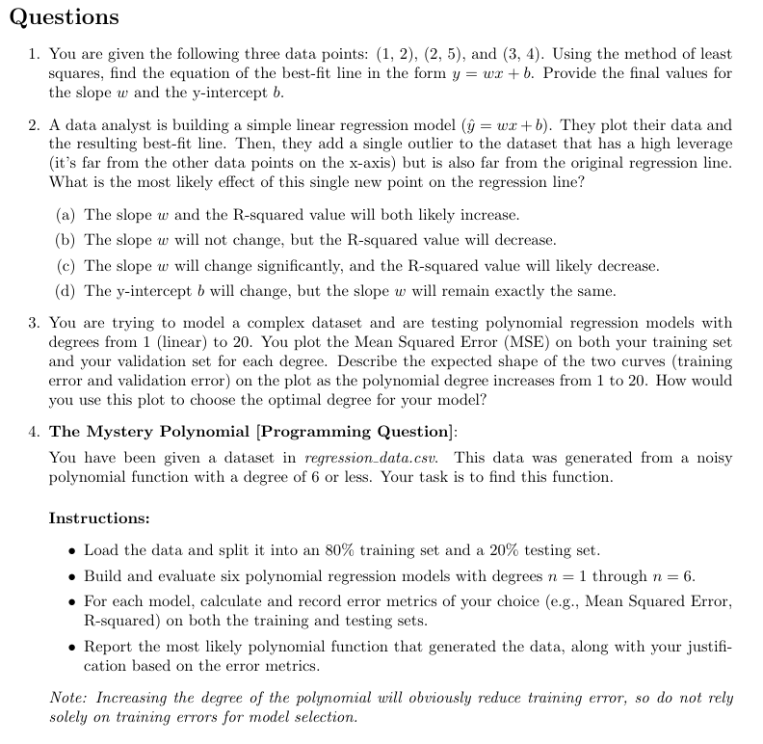
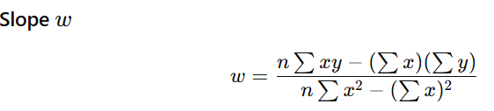
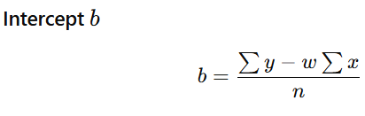
1. Least Squares Best-Fit Line
Data points:
$$\left(1,2),(2,5),(3,4\right)$$
We use formulas:
$$w=\frac{∑(x_{i}-\overset{ˉ}{x})(y_{i}-\overset{ˉ}{y})}{∑(x_{i}-\overset{ˉ}{x})^{2}},b=\overset{ˉ}{y}-w\overset{ˉ}{x}$$

Step 1: Compute means
$$\overset{ˉ}{x}=\frac{1+2+3}{3}=2,\overset{ˉ}{y}=\frac{2+5+4}{3}=\frac{11}{3}$$

Step 2: Compute numerator
$$x_{i}$$ | $$y_{i}$$ | $$x_{i}-\overset{ˉ}{x}$$ | $$y_{i}-\overset{ˉ}{y}$$ | Product
1 | 2 | -1 | $$-5/3$$ | $$5/3$$
2 | 5 | 0 | $$4/3$$ | 0
3 | 4 | 1 | $$1/3$$ | $$1/3$$
$$∑(x_{i}-\overset{ˉ}{x})(y_{i}-\overset{ˉ}{y})=5/3+1/3=2$$

Step 3: Denominator
$$∑(x_{i}-\overset{ˉ}{x})^{2}=1+0+1=2$$

Step 4: Compute slope
$$w=\frac{2}{2}=1$$

Step 5: Compute intercept
$$b=\overset{ˉ}{y}-w\overset{ˉ}{x}=\frac{11}{3}-2=\frac{5}{3}$$

✅ Final Answer:
$$\boxed{y=x+\frac{5}{3}},\boxed{w=1, b=\frac{5}{3}}$$

2. Effect of a High-Leverage Outlier
Key idea:
- High leverage → far in x-direction
- Also far from line → large error
👉 Such a point pulls the regression line toward itself
Effects:
- Slope $w$→ changes significantly
- Fit worsens overall → $R^{2}$decreases

✅ Correct Answer:
$$\boxed{(c)\text{ Slope changes significantly and }R^{2}\text{ decreases}}$$

3. Training vs Validation Error Curve
Expected shapes:
Training Error
- Always decreases as degree increases
- Reason: model becomes more flexible → fits data better

Validation Error
- First decreases (model improves)
- Then increases (overfitting starts)
👉 Shape = U-shaped curve

Visualization (conceptually):
Error
│
│ Validation ∪
│ / \
│ / \
│ Training \______
│
└──────────────────→ Degree

How to choose optimal degree?
👉 Pick the degree where:
$$\text{Validation Error is MINIMUM}$$

Interpretation:
- Left side → Underfitting (too simple)
- Middle → ✅ Best generalization
- Right → Overfitting

✅ Final Answer:
- Training error ↓ monotonically
- Validation error ↓ then ↑ (U-shape)
- Choose degree at minimum validation error

4. Mystery Polynomial (How to Solve)
Since this is a programming-style question, here’s the exact approach + code.

Step-by-step approach
1. Load and split data
- 80% training
- 20% testing

2. Train models (degree 1 → 6)
For each degree:
- Fit polynomial regression
- Compute:
  - Training MSE
  - Testing MSE
  - (Optional) $R^{2}$

3. Compare errors
Key rule:
- Training error always decreases
- Testing error:
  - decreases → optimal degree
  - then increases → overfitting

Python Code (ready to use)

import numpy as np
import pandas as pd
from sklearn.model_selection import train_test_split
from sklearn.preprocessing import PolynomialFeatures
from sklearn.linear_model import LinearRegression
from sklearn.metrics import mean_squared_error, r2_score

# Load data
data = pd.read_csv("regression_data.csv")
X = data[['x']].values
y = data['y'].values

# Split
X_train, X_test, y_train, y_test = train_test_split(X, y, test_size=0.2, random_state=42)

results = []

for degree in range(1, 7):
poly = PolynomialFeatures(degree)
X_train_poly = poly.fit_transform(X_train)
X_test_poly = poly.transform(X_test)

model = LinearRegression()
model.fit(X_train_poly, y_train)

y_train_pred = model.predict(X_train_poly)
y_test_pred = model.predict(X_test_poly)

results.append({
"degree": degree,
"train_mse": mean_squared_error(y_train, y_train_pred),
"test_mse": mean_squared_error(y_test, y_test_pred),
"train_r2": r2_score(y_train, y_train_pred),
"test_r2": r2_score(y_test, y_test_pred)
})

for r in results:
print(r)

How to pick the final polynomial?
👉 Choose degree where:
- Test MSE is minimum
- AND no large gap between train & test error

Example interpretation:
Degree | Train MSE | Test MSE | Conclusion
1 | High | High | Underfit
3 | Medium | Lowest | ✅ Best
6 | Very low | High | Overfit

Final Answer (what to report)
- Best degree (e.g., 3 or 4)
- Corresponding polynomial equation
- Justification:
  - “Lowest test MSE”
  - “Avoids overfitting”

